Camera Hardware Description
Clayton Gumbrell
25 December 2008
Hardware Version 2.0

Description
Refer to data sheets and sample source code for programming details.

PCB Layout
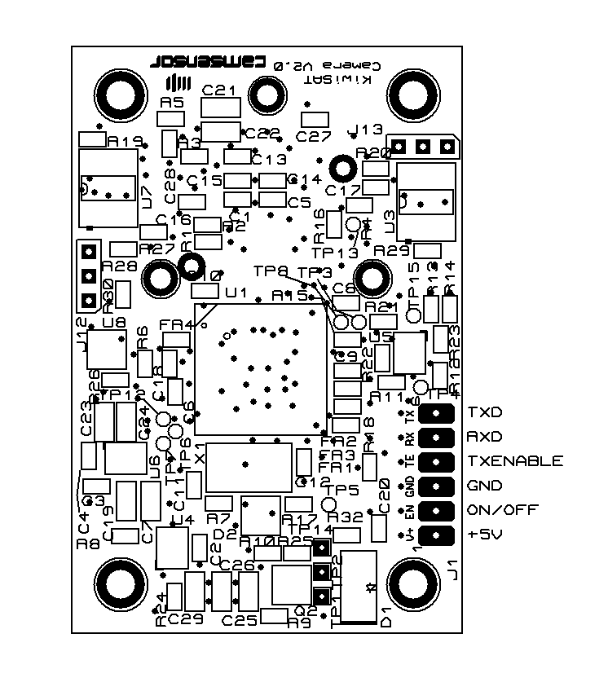
For right-way viewing images, put the right-hand-side of the PCB as shown to the top.

PCB Connections
J1 are the power, data and control connections
Connections | Signal | Description
J1 – 1 | +5V | +5V power
J2 – 2 | ON/OFF | Camera Enable. Pull low to turn camera on
J2 – 3 | GND | Ground (0V)
J2 – 4 | TXENABLE | TXD enable input (optional)  Pull low to enable TXD output  (Not used for KiwiSAT – leave unconnected)
J2 – 5 | RXD in | Serial data input. TTL levels
J2 – 6 | TXD out | Serial Data Output. 5V logic levels

